**s**

**s**

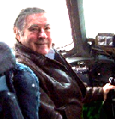

George A. Filer III

New Jersey State Director

MUFON Eastern Region Director

Www.nationalUFOcenter.com. Now receiving 3 million hits a month

January 6, 2017

In special reports, this week’s files cover: Astronaut Gordon Cooper saw UFOs, Hillary Clinton/Alien Pin from the Philly DNC, Roswell’s Alien Creatures Photographed in Ohio, Astronauts Armstrong and Aldrin, NASA Releases Apollo Mission Transcripts, and Military Close Encounter During World War 2.

Unidentified Aerial Phenomena sightings were reported over California, Florida, Indiana, Louisiana, Maryland, Missouri, New Jersey, New Mexico, New York, Oregon, and Vermont.

Unidentified Aerial Phenomena sightings were reported over Australia, Brazil, Canada, Denmark, France, Germany, Portugal, Puerto Rico, and England in the United Kingdom.

The Filer Research Institute feels the scientific study of UFOs is for the benefit of humankind and is an important endeavor. The US Air Force investigated UFOs publicly for more than twenty years under Project Blue Book; and I continue this advanced research. I believe the God of the universe has spread life throughout the cosmos and UFO’s are visiting us in ever-increasing numbers.

# Forward these files to your friends and neighbors.

# Special Projects

Robert White

On July 17, 1962 Major Robert White reported a UFO during his fifty-eight-mile high flight of an X-15. Major White reported: "I have no idea what it could be. It was grayish in color and about thirty to forty feet away."  
Then according to a Time Magazine article, Major White exclaimed over the radio: "There ARE things out there! There absolutely is!"

Eugene Cernan



[Eugene Cernan](http://www.genecernan.com/) was commander of Apollo 17. In a Los Angeles Times article in 1973 he said, about UFOs: "...I've been asked (about UFOs) and I've said publicly I thought they (UFOs) were somebody else, some other civilization."

Ed White & James McDivitt

[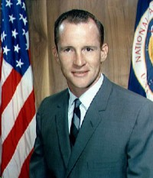](http://www.ocston.org/~rr/astronauts/white-mcdivitt.html) [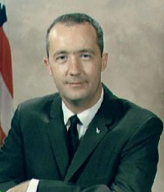](http://www.ocston.org/~rr/astronauts/white-mcdivitt.html)

In June 1965, astronauts [Ed White](http://www.hq.nasa.gov/office/pao/History/Apollo204/zorn/white.htm) (first American to walk in space) and James McDivitt were passing over Hawaii in a Gemini spacecraft when they saw a weird-looking metallic object. The UFO had long arms sticking out of it. McDivitt took pictures with a cine-camera. Those pictures have never been released.

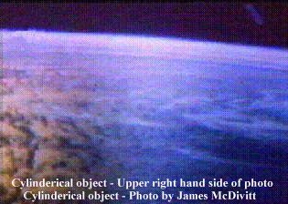 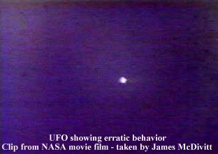

James Lovell and Frank Borman

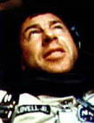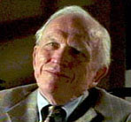

In December 1965, Gemini astronauts James Lovell and [Frank Borman](http://www.pbs.org/wgbh/nova/tothemoon/borman.html) also saw a UFO during their second orbit of their record-breaking 14 day flight. Borman reported that he saw an unidentified spacecraft some distance from their capsule. Gemini Control, at Cape Kennedy told him that he was seeing the final stage of their own Titan booster rocket. Borman confirmed that he could see the booster rocket all right, but that he could also see something completely different.

*During James Lovell's flight on Gemini 7:***Lovell**: BOGEY AT 10 O'CLOCK HIGH.  
  
**Capcom**: This is Houston. Say again 7.  
**Lovell**: SAID WE HAVE A BOGEY AT 10 O'CLOCK HIGH.  
  
**Capcom**: Gemini 7, is that the booster or is that an actual sighting?  
**Lovell**: WE HAVE SEVERAL...ACTUAL SIGHTING.  
  
**Capcom**: ...Estimated distance or size?  
**Lovell**: WE ALSO HAVE THE BOOSTER IN SIGHT...

**Rendlesham Case rada4**

**UFO Moving at Incredible Speed Tracked By Radar | New Video**

|  |  |  |  |
| --- | --- | --- | --- |
|  |  |  |  |

|  |
| --- |
| **[UFO Moving at Incredible Speed Tracked By Radar | New Rendlesham Case Video](https://2.bp.blogspot.com/-DMw6bFW4AFs/WAlG_UtInSI/AAAAAAAAgjk/_EsT-_AEp9MEM_rKtJNLcswQQb7v_-WrgCLcB/s1600/UFO+Moving+at+Incredible+Speed+Tracked+By+Radar+-+New+Rendlesham+Case+Video.png)** |
| **The now-retired controllers say they tracked a bona fide UFO that covered 120 miles in eight seconds, or three sweeps of their radar beam!** |

|  |  |
| --- | --- |
| **The two U.S. Air Force air traffic controllers who were working in the RAF Bentwaters base tower in late December 1980—during the series of incidents collectively known as the Rendlesham Forest UFO Case—have finally discussed their long-held secret on camera.   Ike Barker and Jim Carey first spoke to me in 2007, allowing me to record their revelations on audio tape. But their dramatic, game-changing testimony is now available on video, in an interview appearing in my new**[**documentary film**](https://vimeo.com/ondemand/ufosandnukes)**, *UFOs and Nukes: The Secret Link Revealed*, excerpted here:** | **[Robert Hastings](https://4.bp.blogspot.com/-L-ieWrHz_cQ/WAkVQF8NjcI/AAAAAAAAgjU/x6Ok37h0pr4k5o9A_HYz4Jxey1Nhlg7xACLcB/s1600/Robert+Hastings+(Head+Shot+From+Doc+-+75+px).png) By Robert Hastings The UFO Chronicles 10-21-16** |

**Monday, October 24, 2016**

**UFO Moving at Incredible Speed Tracked By Radar | New Rendlesham Case Video**

|  |  |  |  |
| --- | --- | --- | --- |
|  |  |  | **[Bookmark and Share](http://www.addthis.com/bookmark.php?v=250&pubid=Frank-Warren)** |

|  |
| --- |
| **[UFO Moving at Incredible Speed Tracked By Radar | New Rendlesham Case Video](https://2.bp.blogspot.com/-DMw6bFW4AFs/WAlG_UtInSI/AAAAAAAAgjk/_EsT-_AEp9MEM_rKtJNLcswQQb7v_-WrgCLcB/s1600/UFO+Moving+at+Incredible+Speed+Tracked+By+Radar+-+New+Rendlesham+Case+Video.png)** |
| **The now-retired controllers say they tracked a bona fide UFO that covered 120 miles in eight seconds, or three sweeps of their radar beam!** |

**What happened at Rendlesham Forest?**

**Dubbed the "British Roswell", a similar incident** [**happened in Rendlesham Forest**](https://www.thesun.co.uk/news/2338395/witness-to-britains-roswell-ufo-incident-at-rendlesham-farm-breaks-36-year-silence/) **in 1980.**

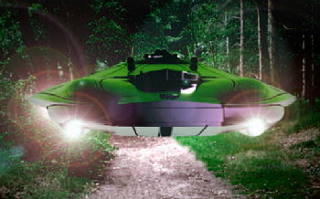

**On December 26, military personnel from RAF Bentwaters and RAF Woodbridge, in Suffolk, saw strange lights in a nearby forest - and three of them were sent out to investigate. Two of them encountered a small, triangular shaped craft - which they later drew images of. One man, Jim Penniston, got close enough to touch the side of the object receiving a message. Two nights later, Deputy Base Commander Lieutenant Colonel Charles Halt and his team also encountered the UFO - and were left baffled by the entire experience.**

**In January 2018, unseen footage revealed former base commander Charles Halt made explosive claims that airmen involved in the case "aliens”. In UFO documentary Unacknowledged it is claimed that Marilyn made the threats after having affairs with both President JFK and Bobby Kennedy, and was seeking revenge as they both simultaneously ended things with her.**

|  |  |
| --- | --- |
| **The two U.S. Air Force air traffic controllers who were working in the RAF Bentwaters base tower in late December 1980—during the series of incidents collectively known as the Rendlesham Forest UFO Case—have finally discussed their long-held secret on camera.   Ike Barker and Jim Carey first spoke to me in 2007, allowing me to record their revelations on audio tape. But their dramatic, game-changing testimony is now available on video, in an interview appearing in my new**[**documentary film**](https://vimeo.com/ondemand/ufosandnukes)**, *UFOs and Nukes: The Secret Link Revealed*, excerpted here:** | **[Robert Hastings](https://4.bp.blogspot.com/-L-ieWrHz_cQ/WAkVQF8NjcI/AAAAAAAAgjU/x6Ok37h0pr4k5o9A_HYz4Jxey1Nhlg7xACLcB/s1600/Robert+Hastings+(Head+Shot+From+Doc+-+75+px).png) By Robert Hastings The UFO Chronicles 10-21-16** |

**The now-retired controllers say they tracked a bona fide UFO that covered 120 miles in eight seconds, or three sweeps of their radar beam! If that were not stunning enough, Carey says the object also made an instantaneous right-angle turn as it left the vicinity. For his part, Barker says he actually saw the amazing interloper as it briefly hovered near the air traffic control tower, describing it as an orange sphere with a series of portholes positioned around its center.**

**The now-retired controllers say they tracked a bona fide UFO that covered 120 miles in eight seconds, or three sweeps of their radar beam! If that were not stunning enough, Carey says the object also made an instantaneous right-angle turn as it left the vicinity. For his part, Barker says he actually saw the amazing interloper as it briefly hovered near the air traffic control tower, describing it as an orange sphere with a series of portholes positioned around its center.**

**[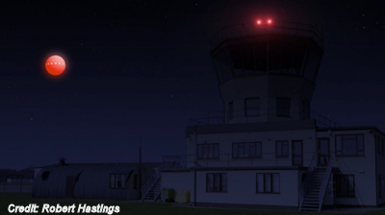](https://1.bp.blogspot.com/-As4YYyBuNqc/WAqL0CQ9VcI/AAAAAAAAgj0/8BWQSIVnhjE7tFGnrcxdYcxXWOt8yfJngCLcB/s1600/Airtraffic+Controllers+Track+UFO+on+Radar.png)**

**Both controllers are emphatic: This was an intelligently-controlled craft whose capabilities far surpassed any current human technology. Significantly, the incident occurred the same night that USAF Lt. Col. Charles Halt—the Deputy Base Commander at Bentwaters—was leading a small group of Security Policemen through nearby Rendlesham Forest, to investigate strange lights that had been reported there. At one point, Halt described seeing an object resembling an eyeball moving through the trees, dripping a molten-metal-like substance.**

**[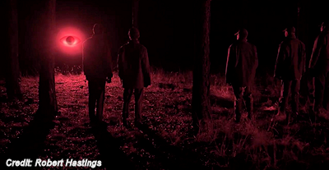](https://1.bp.blogspot.com/-_ruE3f2f1kA/WAqMOtU6H6I/AAAAAAAAgj4/s45RUZ429RIh2MFnA00AKQpUtkcb2ujKQCLcB/s1600/Rendlesham+Forest.png)**

**Skeptics have always dismissed this “UFO sighting” as a misreported observation of the sweeping beam from the nearby Orford Ness lighthouse—despite the fact that Col. Halt has repeatedly said, as early as 1997, that the lighthouse beam was also visible during the incident, but located some 30-degrees away from the strange glowing object.  
  
According to Halt, the eyeball eventually “exploded” and released five smaller disc-shaped craft that raced away in different directions, something confirmed by USAF Security Policeman Rick Bobo, who saw the spectacle at a distance, from the guard tower at the Bentwaters nuclear Weapons Storage Area (WSA).  
  
After awhile, Halt says, three disc-shaped craft higher in the sky were observed doing grid search-like maneuvers. One of them approached his team, hovered above it, and directed a laser-like beam at their feet. After a few seconds, the beam clicked off and the object moved away, in the direction of the WSA. Seconds later, Halt heard excited radio chatter from guards posted at the facility, indicating that beams from the UFO were falling on or near the tactical nuclear bomb storage bunkers!**

**It should be noted that the late Georgina Bruni, while researching the Rendlesham Forest UFO incidents, interviewed a former British military radar operator at RAF Watton, Nigel Kerr, who admitted that an anomalous aerial object had briefly appeared on his screen—for three or four sweeps—the night that Lt. Col. Halt and his team were in the woods.   
  
  
Now that the USAF air traffic controllers’ extensive, detailed testimony is also on the record, we can confidently assert that at least one genuine UFO—a high-velocity, maneuvering, hovering, spherical-shaped craft exhibiting advanced technology—was in the vicinity during the period that Halt described seeing multiple UFOs in the sky.**

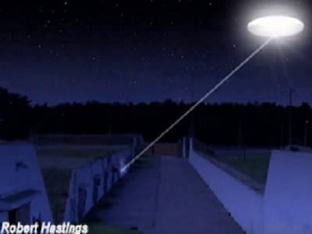

**Nevertheless, questions remain: Why was only one UFO tracked on radar—both at Bentwaters and Watton—when multiple objects were sighted by USAF personnel on the ground? Were all but one of the craft operating in a** [**[](http://www.ufohastings.com/book)**](http://www.ufohastings.com/book)**Stealth-like mode? Or does this discrepancy relate to a given object’s altitude, with most of the UFOs maneuvering beneath the radars’ lower detectability-limit? And why did some observers (Halt and his team) observe discs while others (controller Ike Barker and one guard at the WSA, Charlie Waters) report spherical craft?**

**Regardless, the relevant facts—including a detailed summary of the stunning incident at the WSA—are discussed in**[**my video**](https://vimeo.com/ondemand/ufosandnukes)**. Additionally, a far more comprehensive assessment of the entire Rendlesham Forest Case is featured in my book,**[***UFOs and Nukes: Extraordinary Encounters at Nuclear Weapons Sites***](http://www.ufohastings.com/book)**, available only at my website.**

[**VISIT ROBERT's SITE ►**](http://www.ufohastings.com/)[**WATCH THE ENTIRE DOCUMENTARY, UFOS AND NUKES: THE SECRET LINK REVEALED**](https://vimeo.com/ondemand/ufosandnukes) **See Also:**[**UFO Traveled 120 Miles in 8 Seconds, Say Radar Operators | VIDEO**](http://www.theufochronicles.com/2016/04/ufo-traveled-120-miles-in-8-seconds-say.html)[**One UFO at RAF Bentwaters Appeared on Radar:**](http://www.theufochronicles.com/2012/02/one-ufo-at-raf-bentwaters-appeared-on.html)[**Rendlesham Forest UFO Sighting 'New Evidence' Claim**](http://www.theufochronicles.com/2015/07/rendlesham-forest-ufo-sighting-new.html)

**http://www.theufochronicles.com/2016/10/ufo-moving-at-incredible-speed-tracked.htm**

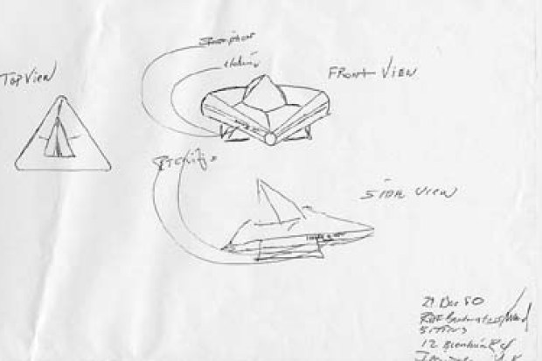

**The Rendlesham Forest incident took place in December 1980 over a series of at least two nights.  
On December 26, 1980, military personnel at the twin bases of RAF Bentwaters and RAF Woodbridge in Suffolk saw a strange light in Rendlesham Forest, which lies between the two bases.  
Three men were sent out to investigate where two of them encountered a small, triangularshaped craft.  
One man, Jim Penniston, got close enough to touch the side of the object. 52 n 13w  
He and another of the airmen present, John Burroughs, made sketches of the craft for witness statements  
Two nights later Deputy Base Commander, Lieutenant Colonel Charles Halt and his team then encountered the UFO.  
He said later: "Here I am, a senior official who routinely denies this sort of thing and diligently works to debunk them, and I'm involved in the middle of something I can't explain."  
Despite an MOD investigation the Rendlesham Forest incident remains unexplained.**

***Cylinders***

**There are reports of large cylinder-shaped objects all over the world. There are no wings or propellers for lift that indicates some type of propulsion that overcomes gravity.**

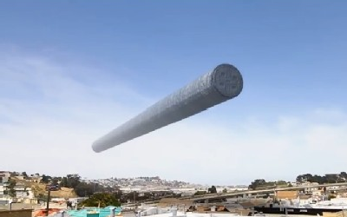

**Many cylinder sightings were reported in the 1400-1500s in Germany and France in particular, with the theory that there was a war amongst alien cylinders and orbs.**

***At sunrise on the 14th April 1561, the citizens of Nuremberg beheld "A very frightful spectacle." The sky appeared to fill with cylindrical objects from which red, black, orange and blue white disks and globes emerged. Crosses and tubes resembling cannon barrels also appeared whereupon the objects promptly "began to fight one another." This event is depicted in a famous 16th century woodcut by Hans Glaser.***



**“Tube” indicates that these objects are hollow or at least have space inside for humanoid beings whereas a “cylinder” could be fairly solid, perhaps the outer casing houses one big machine inside? Thanks to** [**www.ufoevidence.org**](http://www.ufoevidence.org/)**. On occasion a cylinder might be a misidentified aircraft but multiple witnesses claim they have viewed them close enough to discard this explanation,**

**Perhaps they belong to one kind of UFO occupant while the huge orb, saucer, or triangle craft are the motherships of UFO occupants from other places or sources? Or at least these might be “interim ships” which are not as small as scout craft but not as large as motherships. Usually cylinder sightings report no windows and a 100 foot length similar to large aircraft.**

**Presbyterian Minister Barry H. Downing writes, *“I suggest UFOs have played an important role in the history of the world. Reverend Barry Downing in his book "The Bible and Flying Saucers" declares the messengers are here and that the Pillar of Fire and of Cloud are ancient descriptions of UFOs. He and other experts feel that when the Hebrew Scriptures are translated correctly, they describe cylinder or saucer shaped craft with a dome, that carry God's messengers, angels, or the Lord.  The word most often used in the Old Testament for cloud is 'anan,' a word that describes anything that flies except birds and insects. The clouds or 'anan' are described as having attributes not normally associated with fluffy clouds such as flying towards the observer and landing, glowing at night, and carrying passengers.***



**/**

**Reverend Downing states, *"During the exit of Israelites from Egypt they are guarded by a pillar of cloud by day and a pillar of fire by night.' (Exodus 14:24), Sometimes the pillar of cloud is referred to as the "Lord" (Exodus 13:21; 14:24); other references seem to be "the angel of God" (Exodus 14:20), "the glory and brightness of the Lord appeared in the cloud" (Exodus 16:10), "I am coming to you in a thick cloud" (Exodus 19-9), "Mt Sinai was wrapped in smoke because the Lord descended upon it in a fire"* (Exodus 19:18).**

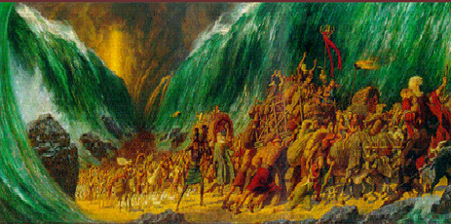

**Obviously, normal clouds cannot carry passengers, so we can assume the Bible is referring to some type of flying craft that hovers in one spot for months. The descriptions often describes coming in the clouds. The power of the Lord met Moses and parted the Red Sea allowing the Israelites to escape from the Egyptian chariots. Later on the top of Mount Sinai God gave them the Laws of God, known as the Ten Commandments. They begin, because "I am the Lord your God, who brought you out of the land of Egypt, out of the house of bondage," "You shall have no other gods before me" (Exodus 20:2,3). These commandments provide a standard of behavior brought in a UFO by the Lord who came from Heaven, so that Earth can fulfill God's plan.**

***God’s angels crush Pharaoh, making sport of Pharaoh’s chariots in the Red Sea. Not surprisingly, modern UFOs have made sport of our technology, and our advanced jet fighters. Why won’t American military leaders just announce that modern UFOs fly circles around our fighters?***

**God is making sport of all the powers. Writing from a scientific perspective, Foster Morrison has said, “*The only identifiable thing the UFO phenomenon is doing is discrediting the scientific and political establishments.* UFOs are an attack on the scientific atheism of our culture. The God of the Bible is alive and well. UFOs are also an attack on blind religious faith. Religious leaders are in for a shock. Not only are the angels of God alive and well, but they are scientifically very advanced. Thanks to Minister Barry H. Downing.**

**GETTY IMAGES**

[**6**](https://www.thesun.co.uk/news/2338395/witness-to-britains-roswell-ufo-incident-at-rendlesham-farm-breaks-36-year-silence/)

**A UFO trail sign at Rendlesham Forest, which has become a tourist hotspot**

**Top of Form**

[**[](https://www.google.com/webhp?hl=en&sa=X&ved=0ahUKEwiOnZLf9NfeAhXMqFkKHVXEAhAQPAgH)**](https://www.google.com/webhp?hl=en&sa=X&ved=0ahUKEwiOnZLf9NfeAhXMqFkKHVXEAhAQPAgH)



**Bottom of Form**

**Search Modes**

**All**

[**News**](https://www.google.com/search?q=ireland+air+traffic+control&source=lnms&tbm=nws&sa=X&ved=0ahUKEwiOnZLf9NfeAhXMqFkKHVXEAhAQ_AUIDigB)

[**Images**](https://www.google.com/search?q=ireland+air+traffic+control&source=lnms&tbm=isch&sa=X&ved=0ahUKEwiOnZLf9NfeAhXMqFkKHVXEAhAQ_AUIDygC)

[**Maps**](https://maps.google.com/maps?q=ireland+air+traffic+control&um=1&ie=UTF-8&sa=X&ved=0ahUKEwiOnZLf9NfeAhXMqFkKHVXEAhAQ_AUIECgD)

[**Videos**](https://www.google.com/search?q=ireland+air+traffic+control&source=lnms&tbm=vid&sa=X&ved=0ahUKEwiOnZLf9NfeAhXMqFkKHVXEAhAQ_AUIESgE)

**More**

[**Settings**](https://www.google.com/preferences)**Tools**

**The Irish Aviation Authority is investigating reports of bright lights and UFOs off the south-west coast of Ireland.**

**It began at 06:47 local time on Friday 9 November when a British Airways pilot contacted Shannon air traffic control.**

**She wanted to know if there were military exercises in the area because there was something "moving so fast".**

**The air traffic controller said there were no such exercises.**

**The pilot, flying from the Canadian city of Montreal to Heathrow, said there was a "very bright light" and the object had come up along the left side of the aircraft before it "rapidly veered to the north".**

[**ADVERTISEMENT**](https://www.bbc.com/privacy/cookies/international/)

**She was wondering what it could be but said it did not seem to be heading for a collision.**

**Another pilot from a Virgin plane joined in and suggested it might be a meteor or another object re-entering the earth's atmosphere.**

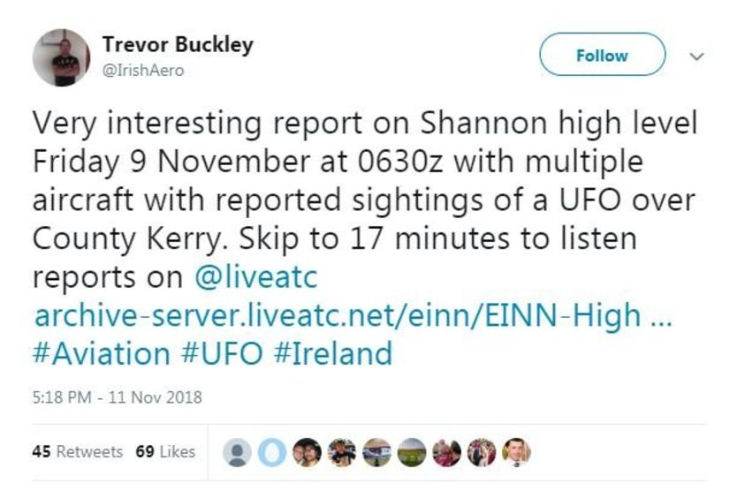**Image copyrightTWITTER**

**He said there were "multiple objects following the same sort of trajectory" and that they were very bright.**

**The pilot said he saw "two bright lights" over to the right which climbed away at speed.**

**ADVERTISEMENT**

**One pilot said the speed was "astronomical, it was like Mach 2" - which is twice the speed of sound.**

**grey line**

**What could it have been?**

**Apostolos Christou, an astronomer from the Armagh Observatory and Planetarium, said what the pilots saw was probably a piece of dust entering the earth's atmosphere at very high speed.**

**"It was most likely what are commonly called shooting stars," he said.**

**"It appears the matter was extremely bright so it must have been quite a large piece of material.**

**"I cannot say from the pilots' description, but it could have been the size of a walnut or an apple."**

**Image copyrightGETTY IMAGES**

**The astronomer said November tended to be a very busy month for such activity.**

**"It also appears there were bits coming off the object and flying past the aeroplane, that is also what you would expect if it was a particularly large rock from space hitting the atmosphere, it would tend to fragment."**

**grey line**

**"Following reports from a small number of aircraft on Friday 9 November of unusual air activity the IAA has filed a report," the Irish Aviation Authority (IAA) said.**

**"This report will be investigated under the normal confidential occurrence investigation process."**

**A spokesperson for Shannon Airport said it would not be appropriate for the airport to comment while the IAA investigation is ongoing.**

**jimMore on this story**

**Lord Mountbatten was very close to Prince Charles - and acted as a mentor to him**

**Back in February, 1955, Mountbatten, who was often referred to as Prince Charles's "honorary godfather" and mentor because of his close relationship with the Duke of Edinburgh, made an official report about a strange encounter his bricklayer Fred Briggs allegedly had with a flying saucer and an alien creature.**

**The report, which was uncovered after Mountbatten's 1979 death at the hands of the IRA, describes how a silver spaceship landed in the grounds of his Broadlands estate in Romsey, Hampshire.**

**The flying saucer hovered above the ground before a man dressed in overalls and a helmet descended from the bottom of the craft, according to the documents.**

**Fred was then reportedly knocked off his bike and held on the ground by an "unseen force".**

* **M onbatten claims have trusted witness has telling the truth**

**[Video UFO spotted by US fighter jet pilots, new footage reveals](https://www.bbc.com/news/av/world-us-canada-42405205/ufo-spotted-by-us-fighter-jet-pilots-new-footage-reveals)**

**[18 December 2017](https://www.bbc.com/news/av/world-us-canada-42405205/ufo-spotted-by-us-fighter-jet-pilots-new-footage-reveals)**

**[The great saucer invasion: The day six 'spaceships' landed in England](https://www.bbc.com/news/uk-england-41110193)**

**[3 September 2017](https://www.bbc.com/news/uk-england-41110193)**

[**Europe**](https://www.bbc.com/news/world/europe)

**ALAMY**

[**6**](https://www.thesun.co.uk/news/2338395/witness-to-britains-roswell-ufo-incident-at-rendlesham-farm-breaks-36-year-silence/) **Top of Form**

**clouds." Job 26**

**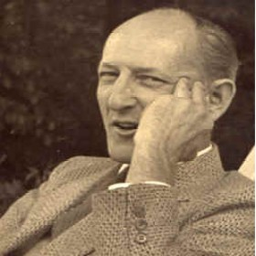*Fire Fighters Guide Chapter 13: Enemy Attack and UFO Potential***

***Part # 5 Why the Secrecy?***

**Nothing helps rumors and panic more than ignorance." Major Donald Keyhoe describes in his book, *Aliens from Space, The Real Story of Unidentified Flying Objects,* " the difficulties he had in 1957 in trying to get the truth from government agencies after he was director of NICAP, the world's largest UFO research organization with over 30 subcommittees in the U.S. and abroad.  According to some UFOlogists the attempts at cover-up by the CIA extend to destruction of evidence that it could not confiscate. Apparently some of our nation's important leaders have been denied access to some UFO secrets in the possession of an agency of the United States, the very existence of which is classified above top secret.**

**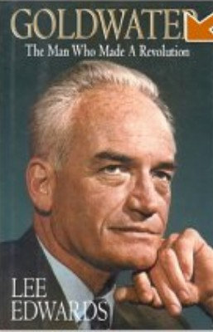 Senator Barry Goldwater, a retired Air Force Reserve Brigadier General and pilot with many decades of flying experience, was quoted as saying "I certainly believe in aliens in space.  They may not look like us, but I have very strong feelings that they have advanced beyond our mental capabilities."**

**He said he was refused permission to check the Air Force files on UFOs and added, "I think some highly secret government UFO investigations are going on that we don't know about--and probably never will unless the Air Force discloses them." He said that he put  faith in the reports of the Air Force, Navy, and commercial pilots who  reported instances where a UFO would fly near them--right off their plane's  wing--and then just zoom away at incredible speeds. "I remember the case in Georgia in the 1950s of a National Guard plane going after a UFO and never returning. And I recall the case in Franklin. Kentucky, when four military planes investigated a UFO. One of them exploded in midair and no one knows why." Unleashed by the policy of Glasnost (greater openness) the Soviet media felt free to include accounts of UFO sightings. A Tass report of October 10, 1989, reported a large shiny ball or disk hovering over a Voronezh park; residents saw the UFO land and three creatures similar to human beings emerged, accompanied by a robot.  Apparently the Russians felt no need to suppress this report which was poked fun at in Newsweek and Time magazines but not in U.S. News and World Report:**



**"A scant few decades ago, both the U.S. government and the media treated flying objects as no laughing matter--which even Congress looked into. In 1966, Representative Ford responded to a rash of sightings in his home state of Michigan by calling for, and getting, a House hearing on UFOs."  Both President Ford and Reagan were interested in UFOs. Thanks to William Kramer Ph.D and Charles W. Bahame, J.D.**

**The Rendlesham Forest incident took place in December 1980 and has been dubbed Britain's Roswell**

**Steve went out into the forest where he remembers seeing a large group of other military personnel had already gathered including Staff Sgt Jim Burroughs, Airman First Class Edward Cabansag and Airman First Class Larry Warren.**

**Describing the UFOs, he said: “They looked like fluorescent coloured lights, like red and green, glowing lights and that’s what they looked like.I could see them hovering over the treetops like an eye that was almost following everybody.”**

**He added: “It was real kind of quiet and this thing hovering over the trees, and you were like kind of tracking it and like ‘what is this?’. And it was like following, it was like watching us, that’s what it looked like to us. It seemed like something watching us.**

**“From what I remember it was like aglow, it was really glowing like a reddish, greenish light. It was really glowing, like something was really hot and it was just glowing.”**

**JONNY DILLON**

[**6**](https://www.thesun.co.uk/news/2338395/witness-to-britains-roswell-ufo-incident-at-rendlesham-farm-breaks-36-year-silence/)

**This letter is the MOD's response to Rendlesham Forest UFO incident**

**He also recalled seeing Colonel Charles Halt there, who made a tape recording describing how beams of light were being shone down by the UFO. He has written an explosive new book called The Halt Perspective describing his close encounter.**

**Mr Longero said: “Col Halt came afterwards, after all that was called in. I remember him turning up, that’s when they kind of gathered everyone around and said this is what we are going to do, and everybody kind of dispersed and did what they were told to do.**

**"I remember we had a little briefing right there and everybody was just like, we just could not believe what we were seeing. Your adrenalin was flowing and I remember people saying like ‘what is that?’.**

**Many civilizations cut off from one another thousands of years ago all use similar writing to communicate?  If we are to put trust in ancient text, if we are to have ‘faith’ that these writings are true, than we must come to the conclusion that we have been and are being visited by intelligent life not of this earth and what better place to look for proof than in the Bible.  Ezekiel I, 4 - 28  *" And I looked and behold a whirlwind came out of the north, a great cloud, and a fire enfolding itself, and a brightness was about it, and out of the midst thereof as the color of amber, out of the midst of the fire the likeness of four living creatures. And this was their appearance; they had the likeness of a man.* "**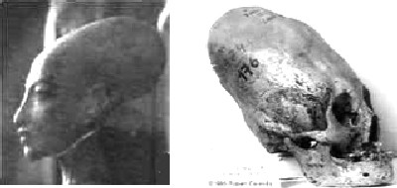

**PROOF OF ALIEN CULTURES:  The three photographs are taken from two different places on the globe and yet all show elongated skulls that cannot be of human origin. If one looks at all of the evidence, we must admit that we truly are not alone . More than 40,000 Americans have taken out insurance against being abducted by aliens.**

**Mars  
Studies conducted by NASA and others have determined that water, rocket propellant and chemicals needed to sustain a human outpost could be manufactured from Martian soil and ice caps (right). Future astronauts might set up production plants that expand as others arrive. Eventually, the Mars base could become a resupply base.**

**Asteroids  
Scientists believe these leftovers of the solar system's formation, floating between the orbits of Jupiter and Mars, may contain rare elements and water. Mining these rocks, some as big as mountains, will be neither easy nor cheap. Using technologies previously developed to extract precious materials from the moon or Mars could make asteroids an attractive target, especially for a permanent human colony on the red planet. Astronauts would first practice rendezvous with asteroids. Then, after studying them, crews would return with mining equipment. Excavated ore could be trucked to a Martian outpost.**

**Titan  
As early as next year, we may learn whether Saturn's largest moon, Titan, preserves organic molecules similar to those believed to exist on primeval Earth. The Cassini-Huygens spacecraft is designed to determine whether the atmosphere of Titan indeed contains ammonia and hydrocarbons such as ethane and methane. All these chemicals contain a common element: hydrogen. Extracting this gas in a minus 400°F environment could be easier than on Earth since it would be already liquefied and ready to be used as the most powerful chemical rocket fuel. With organic chemicals as ingredients, a limitless array of synthetic materials could be manufactured.**

**Space Sails  
Earthlings first learned about the existence of the solar wind 35 years ago when *Apollo 11* astronauts Neil Armstrong and Buzz Aldrin deployed a silver-colored sheet on the moon. Scientists wanted to intercept particles coming from the sun.**

**Taking advantage of this natural source of energy made perfect sense to some within the space community. A lightweight sail (above) could be folded and launched into space. Once in the vacuum of space, the frame attached to a spacecraft would deploy and the square-mile sail could push a spacecraft through interplanetary space faster than conventional propulsion systems, and reach the outer planets in one-fourth the time spacecraft currently take.--*S.C.***

I actually tend to think that few civilizations will end up building Dyson spheres. Again, my suspicion is that it's possible (though not easy in the initial stages) to develop techniques for generating and containing negative energy/mass, and then you have warp drive/wormholes. At that point you can colonize (or terraform and then colonize) new planets. Most likely you don't want more than two or three billion inhabitants per planet (Earth is probably currently overpopulated). You'll primarily use FTL (some sort of wormholes or else readable quantum entanglement) for communication and not put out significant radio signals. So, I would really expect to *only* see regular planetary systems. We can't really say anything for certain until we get enough telescope resolution to see Earth-like planets and whether (1) they show evidence of biological processes like photosynthesis and oxygen-rich atmospheres, and (2) lights illuminating metropolitan areas.

Even such observations would not rule out intelligent life of very different forms than those found on Earth.

* **WHY WAS THE NEWS BANNED?**
* **Why was New Zealand museum curator Noel Hilliam warned to keep out of a local archaeological forest area or his life would be in danger?**
* **2. BRAVE SCIENTIST MURDERED**
* **Who murdered scientist, Dr Mallove after he announced that “official science is not really intent on truly expanding scientific knowledge, when some scientific dogmas and theories are put at risk”?**
* **3. SCIENTISTS AND MEDIA LAUGHED AT HIM**
* **After national radio broke news that amateur historian/ archaeologist Val Osborn had found evidence of Phoenician mining operations in Australia around 1000 B.C., a Central Queensland University representative went on the six o’clock news to debunk Osborn’s discovery. Why was he represented as an archaeology expert when in reality he was an art history teacher?**
* **4. LISA'S "TOP SECRET" ORDERS**
* **Lisa Kerr, while working with the New Mexico Parks Department, helped excavate a large number of giant human skeletons exposed after a washout. Why were she and other workers obliged to sign "secrecy documents" ensuring that they would never divulge details of their participation in this undertaking?**
* **5. THE FARMER WHO NEARLY WENT TO PRISON**
* **Why was a poor farmer threatened with being sent to prison because of some stones found on his property?**
* **6. EVIDENCE DESTROYED**
* **Why would institutions like the Smithsonian, founded to disseminate “knowledge for the benefit of mankind”, dump priceless artifacts in the ocean?**
* **7. CANCER CURE BLOCKED**
* **When a safe, natural cancer cure was discovered by brilliant German research scientist, Dr. Johanna Budwig, a seven-time Nobel Award nominee, why was it blocked by the very agency that is designed to protect your health - the FDA?**

**Thanks to Hamilton**

**Russia USO Secrets**

**It has often been said that we know more about the surface of the Moon than we do about the world’s seas and oceans. The study of USOs (Unidentified Submersible Objects) is a case in point. For years, strange phenomena have been reported by people at sea, especially by navies around the globe. Although many of the USO files of the Soviet and Russian Navy remain secret, some have become available due to the painstaking efforts of dedicated researchers. Paul Stonehill and Philip Mantle reveal strange encounters by the Soviet and Russian Navy with things that are not supposed to exist. Here you will read about the mysterious kvakeri, the “swimmers” of Lake Baikal, the oddities of Issyk Kul, inexplicable events within the forbidding Arctic Ocean, and much more. Most of these stories have never been told outside of Russia or the former Soviet Union. They provide yet more evidence that we are not alone. Indeed, they suggest a permanent presence of something unusual in the depths of Earth's large bodies of water.UFOs over the Lapley Sea**



**The former head of the fleet of the Russian Navy Admiral Vladimir Chernavin describe encounters that had been declassified Russian sailors with three types of UFOs: cymbals (discs), drums and cigar-shaped. The Admiral said that the former Soviet Navy watch had gathered a large number of UFO sightings in those decades in various regions of the world.**

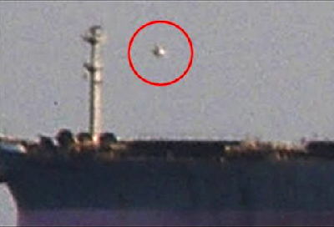

**Weekly meetings on encounters with ships from another world were documented by the section chief former deputy director of exploring the Oceanographic Commission of the Academy of Sciences of the USSR, the captain of the first rank Dr. Vladimir Azhazha that launched a new career as a UFO investigator after his time in the Navy. All former senior naval officers noted that about half of UFO encounters occur at sea. Statistically, 60 percent occur in the Atlantic and the Pacific, 10 percent in the Mediterranean and the rest in other waters. But of all the meetings around the world, some of the most amazing - and disturbing - incidents have occurred in the Bermuda Triangle. [See:** [**Strange light phenomena seen by Christopher Columbus in the Bermuda Triangle**](http://conspiraciones1040.blogspot.com/2013/03/extranos-fenomenos-luminosos-visto-por.html)**]. Many men have seen [UFOs] and have not been confused**

**While conducting naval maneuvers in the Pacific, six Russian submarines found mysterious in their sonar echoes. None of the sonar technicians on any vessel could identify the signature of the echoes, nor was able to determine that the object that their instruments were reading. Everyone agreed, even, that the object was huge and traveling below their submarines. The submarines were under orders not to break formation or to surface, but all six Russian submarines surfaced when sonar operators confirmed the gigantic stranger was quickly approaching them. Unidentified submarine object (USO) ascended quickly and came out of the ocean. The USO surfaced and flew into the air and disappeared quickly.**



**The book** [**UFOs and Water by Carl W. Feindt is the best book available concerning this subject. Amazon.com: Books**](http://r.search.yahoo.com/_ylt=AwrBT.RRwkdUn50AIMtXNyoA;_ylu=X3oDMTEzNzFsbG5uBHNlYwNzcgRwb3MDMwRjb2xvA2JmMQR2dGlkA1ZJUDUzNV8x/RV=2/RE=1414017746/RO=10/RU=http%3a%2f%2fwww.amazon.com%2fUFOs-Water-Carl-W-Feindt%2fdp%2f1450095348/RK=0/RS=e0EC82zZkwuuXo7AUo0aO7G_aDk-)

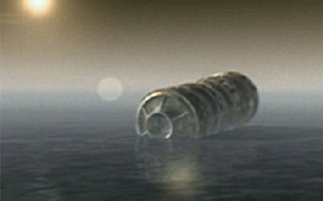

**Azhazha Captain confirmed another declassified** [**Translated from Russian**](http://svpressa.ru/issue/news.php?id=11385) **, said:   
"*There is evidence that the sailors of the Pacific fleet how the remote waters of the Pacific, observed in the cylinders 'suspended', of which the smallest flying saucer UFO, dived into the water, sky and then back again to the master cylinder, and then flew away."***

**Fantastic cylinders seen in Pacific Ocean.**

[***http://conspiraciones1040.blogspot.com/2012/07/ex-oficiales-navales-rusos-de-alto.html***](http://conspiraciones1040.blogspot.com/2012/07/ex-oficiales-navales-rusos-de-alto.html)

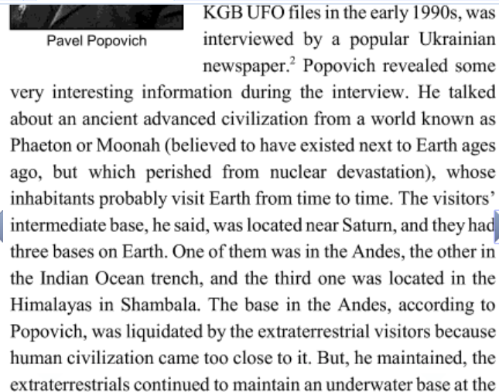

**https://www.amazon.com/Russias-USO-Secrets-Unidentified-International/dp/1532898401**

# UFO Sightings in the United States

# Arizona Light

# California Object

# Florida Lights

**New Jersey Cylinder**

Atlantic City-- My nephew was looking out window from passenger side backside on November 15, 2018, he asked me what the object was on my side, right side. First I did a whole checklist in my head and when I couldn’t explain it . I started filming. It was bright like a Star and shaped like a tic tac. It hovered in what looked like downward direction. It was there until we were to far away.

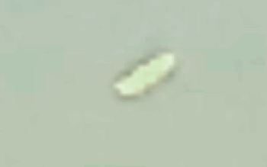

# Washington Lights

# Worldwide UFO Sightings

# Canada

UK

Sheffield -- At back door to the house letting my dogs out for a wee at 03:00 a.m. U.K. time and place in a little village called Whitwell Nottinghamshire between Sheffield and Nottingham. (Activity has happened at lot more frequently in this certain area). It was a clear sky and was looking at the stars waiting for the dogs to finish their business and this large object caught my eye has it moved in to my field of sight in an instance a little like a shooting star without a tail. I had no idea what it was but I know it wasn’t a drone, plane, helicopter or planet/star mainly due to the movements and speed/accelerations/de-accelerations it was making. The instant it came in to view it looked like a bright intense green and orangish orb with a four pointed star around it, as it stopped dead in to a hovering position (slightly swaying in an upside down arc motion) each point grew and was different, the 2 points on either side of the object was long really long a few hundred feet (judging from rooftop in the foreground) and they was bright green pulsating kind off, it’s easy to explain by drawing it. The point coming from the top was orang/red not as bright as the green. And quite short 50ft or more (guessing) and the point coming from the bottom of the craft was bright blue/white, again shorter than the points from the side and longer than the one on the upside of the craft. The blue/white point on the under side grew in length straight down and the bottom of the beam was blocked by houses in the foreground. It changed shape and I took a lot of pictures, some from burst shots with sequences using my iPhone 6s+ The camera wasn’t good enough to catch any stars in the sky even zoomed full. The whole time of sighting, lasted around 40 mins it shot straight upwards with amazing acceleration I could see it still at a good height because of the clear sky it just kept shooting up now just after it looked to have turned course at a right angle it flashed bright like a blink of light can’t explain it well enough and it was gone. I put my iphone in my pocket and came back to bed. I heard a helicopter in the distance (maybe) once I was back in bed. At the time of the sighting it was dead quiet but it was only 03:30 in the morning. I kind of felt like it knew I was watching it (hard to explain!). I’ve got loads of pics which I showed my father mother and wife later on in the day I zoomed in to the pictures and changed the saturation and highlights etc...! They look amazing you can clearly make out a shape some sort of field around it perfect shape and lights and colours in the pics I only used the standard iPhone editing software on the phone, I’ve kept all the originals untouched by using screenshots and zooming in. I’d love to know what somebody with the right equipment could see the pictures are great they’ve really shocked me! Any body can have copies sent to them if they tell me how and where too..! I’d love to see what’s in the pictures what I can’t get to see, but the other thing is as I looked closely with my family they pointed out another in the pictures at the west of the one I knew I’d caught you can see these change shape and colours on the burst shots and also see windows or doors around the craft...! I’m so proud of getting these shots but the craft looked different to the naked eye as the pictures you can see that the object is metallic as it’s reflecting light on one side of it which would have been my right...! Underneath where it was hovering would be trees, a limestone quarry with water in part of it and a Neanderthal site known as Creswell Craggs which has a lake and ancient caves with surounding area consisting of fields and woodlands if it was further away than I estimated it would have been above a place called Clumber Park which is a massive woodland are again with a huge lake. I only have the option of leaving 5 photos I took around 159 and I don’t which are the best without going through them all. I’ve included one edited taking saturation and highlights etc, one zoomed in of the original, one original, one showing reflection at a point and one photo bust of 20 or so if it sends as that...! Hope somebody sees them who can shed light or enhance the pics I’ve got the rest stored on my phone where they’ll stay until somebody asks me but they’re available free of charge I’d just like some light shedding on this please...!

# Support Earth Changing Research

I have put together a DVD of the last twenty years of Filer's Files for you with hundreds of great photographs and UFO sightings that will explain the phenomena and the importance to your life and your family. Additionally, I have included my book within the DVD that includes George Ritter’s exciting abduction story told by Linda Moulton Howe. Broadcaster David E. Twichell joined me to write the book. We are asking for a donation of only $50 that includes next year’s subscription and our book. Please include your e-mail address and mailing address.

You can also go Pay Pal and make payment to Majorstar@verizon.net

https://www.paypal.com/us/webapps/mpp/make-online-payments

When you send in a subscription, please include your latest E-mail address. Do not miss the latest images of UFOs from Earth and Mars. Sign me up right now for Filer’s Files.

Send check or money order to:

George Filer, 222 Jackson Road, Medford, NJ 08055.

Here are the links to our book on Amazon http://www.buybooksontheweb.com/Product.aspx?ISBN=0-7414-2812-1 or http://www.amazon.com/Filers-Files-Worldwide-Reports-Sightings/dp/0741428121/ref=sr_1_2?ie=UTF8ands=booksandqid=1272940324andsr=1-2

JOIN MUFON!

Become a MUFON member today! Benefits of membership include a subscription to the monthly UFO Journal that contains current investigations, sightings reports, articles by world-renowned researchers and more. To join now, http://www.mUFOn.com/

Filer’s Files is copyrighted 2017 by George A. Filer, all rights reserved. Readers may post the COMPLETE files on their Web Sites if they credit the newsletter and its editor by name, and list the date of issue. These reports and comments are not necessarily the OFFICIAL MUFON viewpoint. Send your letters to Majorstar@verizon.net

Sending mail automatically grants permission for us to publish and use your name. Please state if you wish to keep your name or e-mail confidential.

CAUTION MOST OF THESE ARE INITIAL REPORTS AND REQUIRE FURTHER INVESTIGATION. If you wish to stop receiving these files, please send a message to Majorstar@verizon.net.

Filer’s Files salutes our fighting men and women Georgie Filer and Eddie Pedrick my grandsons who both drowned. We pray that God will bless those who read these files spiritually